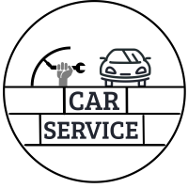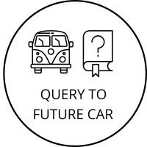

***REQUIREMENTS DOCUMENT***

by

Tolga Çobanoğlu

Table Of Contents

***1 What is Central Car Policy?*** 3

***2 HOW DOES IT WORK ?*** 4

***3 REQUIREMENTS*** 5

***3.1 FUNCTIONAL REQUIREMENTS*** F1: Authorized staffs signs up system. 5

***3.2 NON-FUNCTONAL REQUIREMENTS*** 5

***4.USE CASE ANALYSIS*** 7

***4.1 ACTORS*** 7

***4.2 USE CASE DESCRIPTIONS*** 7

***4.3 SCENARIOS*** 10

***4.3.1 EXPERT SCENARIO*** 10

***4.3.2 SERVICE SCENARIO*** 12

***4.3.3 ADMIN SCENARIO*** 14

***4.3.4 PEOPLE SCENARIO*** 15

***5. REFERENCES*** 16

# ***1 What is Central Car Policy?***

Central Car Policy is a project that aims to reduce the probability of victimization of the buyer in the second hand car market in Turkey to the lowest probability by manipulating the information about the vehicle by the seller.

Central car policy is a policy designed for a single-center reporting system for repair shops, authorized services and appraisals. I would like to present this article, which I cited as evidence while defending the will reduce the likelihood of information being manipulated.[1] "As noted in Transparency International's Global Corruption Report 2003, "information is perhaps the most important weapon against corruption." And absence of, or inaccessibility to, information often creates a sense of disempowerment, mistrust and frustration.".

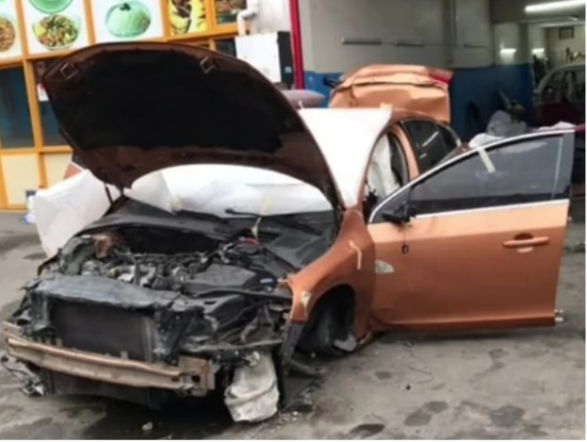 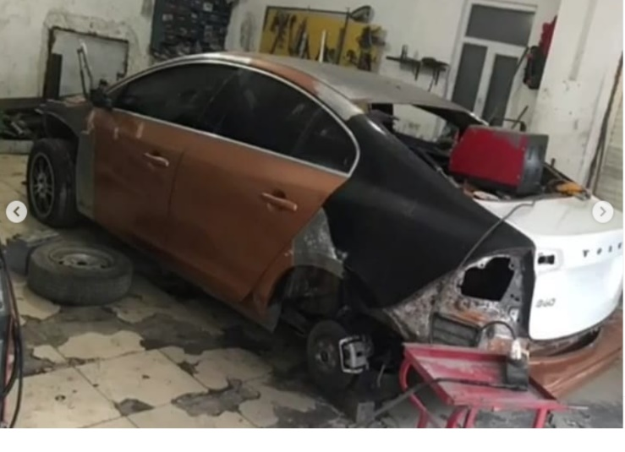

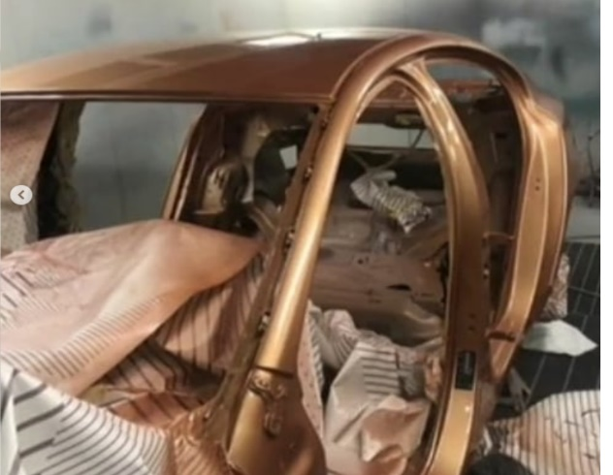 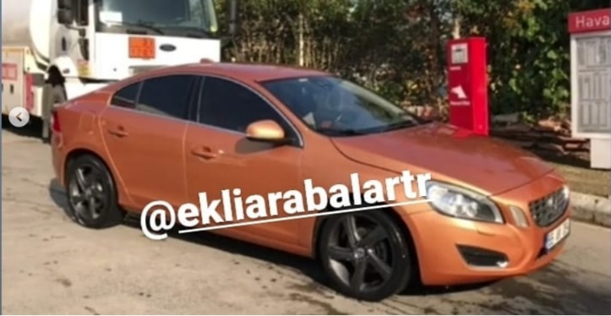

These photos are from Turkey. If you have this car out of the technical service, when factors such as insurance are not involved, this does not affect the tramer record, which qualifies the amount of damage in accidents involving any type of vehicle. You can reach these photos by doing a very short research on the internet and social media for the images you see above.The fact that these photos are so accessible can be shown as proof that they are too many.The car in the picture includes three different cars (which we can observe from the picture), namely itself, the back and the trunk.However, if we do not show an appraisal after the repair process (there is also the case that the appraisal does not understand when we do), it is not possible to understand this difference with the naked eye unless there is a seller's declaration when we receive it directly.As a result of these observations, we conclude what this policy is and why it should be mandatory.

Below, we will put the pieces together like a puzzle by explaining their main features and how they work.

# ***2 HOW DOES IT WORK ?***

Since there are two different clients and four different user type, I will discuss the working principles of each one by one.

In general, creating and updating the database with the incoming data.These data coming from different clients.Clients communicate with database.

Car Service Client  
The car came to the car service for any reason. The processes were done and finished. Before the car leaves the service, the authorized person logs these transactions into the system one by one ,database is updated and a PDF is created at the end of the registration, which can optionally forward it to the owner of the car.

Expert Client  
The car comes to the expert for analysis. The person who will do the appraisal will simultaneously enter the results of the places he has checked into the system. The steps in the application will also guide him and reduce the risk of making mistakes. When the entered values are finished, the database is updated and a PDF of the report is created, according to the vehicle owner's request. The PDF can be shared or viewed by asking the query application at any time.

Query Client  
It is an application that anyone can use. It is an application that displays the data of the vehicle according to the entered license plate. It will return two different results, the first is vehicle information and explanations, the second is the vehicle's expertise reports.

Admin Client  
It makes the approvals of the enterprises that will be members of the system and displays the records of the events in the database.

# ***3 REQUIREMENTS***

## ***3.1 FUNCTIONAL REQUIREMENTS*** F1: Authorized staffs signs up system.

F2: Employees make car query.

F3: Employees display car’s details and reports.

F4: Service employee creates service report.

F5: Service employee insert service report to sytem.

F6: Expert employee creates analysis report.

F7: Expert employee inserts analysis report to system.

## ***3.2 NON-FUNCTONAL REQUIREMENTS***

NF1: Security

The authorized staffs must enter the activation code sent to their e-mail to approve their application.

Unless the admin approves the registration to the system, there will be no sign in to the system.

Employees activate with a code that they want to log in to the application for both expertise and service.

NF2: Auditability and Control

Admin views the report activities for his reason she/he can easily manage operations. In an undesirable scenario, it can be intervened quickly.

NF3: Performance

Applications query will be response to O(N) complexity.It will check one by one is input as car license plate is exist or not.

Uploading the generated reports to the system may vary depending on the network speed.

NF4: Data Integrity

In order to protect the integrity of the data, so that the databases are not manipulated with artificial data, there is a verification process for registering and logging into the accounts in the system. If the passwords are stolen, the information in the database is kept in a hashed and encrypted form.

NF5: Adaptability

Since we aim to go through a process with Solid principles and agile approach during the implementation phase, we aim to keep up with the incoming change request quickly thanks to solid and agile.

NF6: Usability

We design the designs in this way, aiming to produce the application in a user-friendly way, as we have presented in the project proposal before.

NF7: Reusability

We use Firebase, Google's real-time service for the database. It allows us easy transitions between platforms. Since later features will come, for example, only design will be required on the iOS platform, database queries will remain the same anyway.

NF8: Extensibility

We want the user to share their experiences with us by placing a "give us feedback" button somewhere on the login screen. Then we evaluate them and add new features in the releases. In this way, we support our Usability feature.

NF9: Portability

It will run on Android phone devices and will be easy to install for all.

NF10: Compatibility

We will design our application for devices with a minimum Android 9 version. The reason we chose Android 9 is because we aim for the optimum amount of devices.

NF11: Capacitiy

Since we will use a free plan in this project, the API provides us with 1GB of storage, 20K writes/day for writing, and 50K reads/day for reading.

# ***4.USE CASE ANALYSIS***

## ***4.1 ACTORS***

A1: Authorized staff, who is the owner, general manager, area manager.

A2: Employee is the worker of service or expert.

A3: Admin, who is the authorized staff from the ministry, parliament.

A4: People, who is live in Turkey and has this application.

## ***4.2 USE CASE DESCRIPTIONS***

***Use Case Description:*** Authorized staff wants to sign up to system.

***Use Case Name:*** Sign up to system.

***Use Case ID:*** UC1

***Use Case Actor:*** Both expert and service authorized staff,admin.

***Normal Flow:***

1. Authorized staff select which one is her/his sector(expert or service).

2. Select sign up.

3. Fill the inputs.

4. Check inputs conditions like, is password valid or not, is e-mail exist on system or not etc.

5. Insert slave database information.

6. Send activation code to e-mail.

7. Check valid code or not.

8. Admin verify account.

9.Insert information master database.

10.Use case ends.

***Alternate Flows:***

4A1: Inputs are not valid.

1. Display error.

2. Go to step 3.

***Use Case Description:*** Employee analyze car.

***Use Case Name:*** Analyzce car

***Use Case ID:*** UC2

***Use Case Actor:*** Expert employee

***Preconditions***: Expert account must be register to system.

***Normal Flow:***

1. Employee analyzes car.

2. Sign in system.

3. Enter activation code.

4. Create analysis report.

5. Insert analysis report to system.

6. Share report to customer.

7. Use case ends.

***Alternate Flows:***

**2A1:** Wrong sign in inputs.

1. Display error.

2. Go to step 2.

**2A2:** Wrong activation code.

1. Display error.

2. Go to step 3.

***Use Case Description:*** Admin view activities.

***Use Case Name:*** View report’s activities

***Use Case ID:*** UC3

***Use Case Actor:*** Admin

***Normal Flow:***

1. Admin sign in to system.

2. List to report’s activities.

3. Use case ends.

***Use Case Description:*** Admin verify register request from the expert and service.

***Use Case Name:*** Verify register request

***Use Case ID:*** UC4

***Use Case Actor:*** Admin

***Normal Flow:***

1. Admin sign in to system.

2. Accept or reject to request.

3. Use case ends.

***Use Case Description:*** Admin view activities

***Use Case Name:*** View report’s activities

***Use Case ID:*** UC3

***Use Case Actor:*** Admin

***Normal Flow:***

1. Admin sign in to system.

2. List to report’s activities.

3.Use case ends.

## ***4.3 SCENARIOS***

### ***4.3.1 EXPERT SCENARIO***

1. Authorized staff sign up the system.

2. Enters activation code.

3. Admin verify the enrollment.

4. Employee sign in query to system.

5. Enters activation code.

6. Customer bring the car to expert.

7. Employee analyze the car.

8. Employee create analysis report on system.

9. Employee insert analyze report to system.

10. Employee can share report PDF with customer.

Expert scenario’s use case diagram,

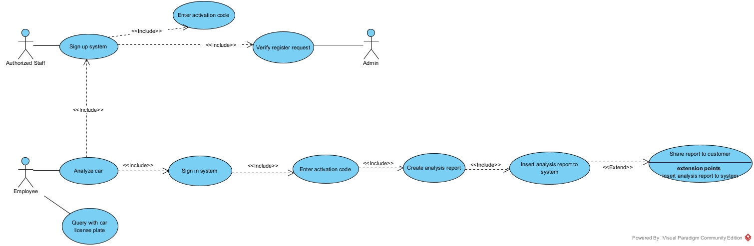

### ***4.3.2 SERVICE SCENARIO***

1. Authorized staff sign up the system.

2. Enters activation code.

3. Admin verify the enrollment.

4. Employee sign in query to system.

5. Enters activation code.

6. Customer bring the car to expert.

7. Employee repair or maintenance the car.

8. Employee create done work's report on system.

9. Employee insert report to system.

10. Employee can share report PDF with customer.

Service scenario’s use case diagram,

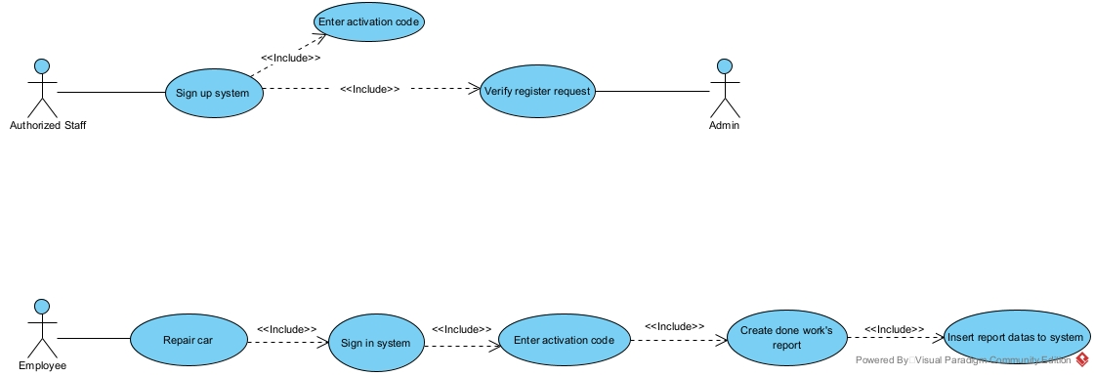

### ***4.3.3 ADMIN SCENARIO***

1. Verify the enrollments.  
2. View to transactions.

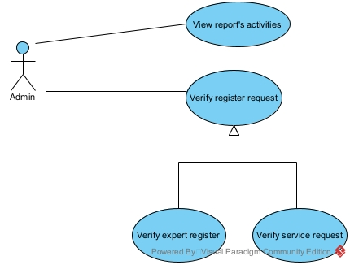

### ***4.3.4 PEOPLE SCENARIO***

1.Query to expert reports.

2. Query to car details.

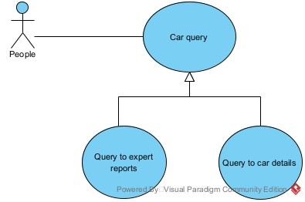

# ***5. REFERENCES***

[1] <http://www.foresttransparency.info/background/forest-transparency/32/transparency-and-the-right-to-information/>